Back End

Softwares

* JDK 1.8
* Eclispe IDE
* MySQL database
* Maven
* Node.js
* Angular CLI
* VSC

Run the queries provided in CreateQueries-MySQLDB.sql on mysql database

It will create database *profile_contact_db* and two tables will be created

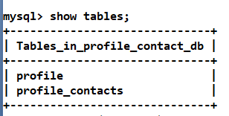

Running backend:

Note: Ensure Java & Maven is installed and mvn path is configured

1. Open terminal & navigate to the my-contact-system folder where you have pom.xml
2. Enter *mvn clean package* command



1. You will get a target folder and a jar file, now you execute the jar using the command

*java -jar target\jar-file-name.jar --server.port = 9090*



1. Tomcat server starts in 9090 port and you can use below URI’s to call the webservices

Back End services are developed with Spring Boot and REST

Below are API’s URL

1) Get Contact API: /api/profile/{userId}/contacts

2) Search Contact by Name API: /api/profile/{userId}/{name}

3) Store Profile API: /api/createProfile

4) Authenticate API: /api/login/{userId}/{password}

5) Get Profile API: /api/profile/{userId}

6) Update Password API: /api/updateProfile/{userId}/{password}

7) Delete Profile API: /api/profile/{userId}

8) Delete Contact API: /api/profile/{userId}/delete/{contactId}

9) Add Contact API: /api/profile/{userId}/addContact

Front End

Front End user interface can be developed using Angular or React or Vue.js.

Here we have used angular framework and bootstrap.js to style the angular components

Running the angular app

Navigate to the *mycontacts-app-ui* and hit the below commands

*npm install*

* *installs the node_modules*

*npm start*

* *runs the application*

Note: mycontacts-app-ui runs by default on 4200 port and it connects to backend webservice 9090 port from its code, hence run your back end on 9090 port only.

Diagram for Contact Management System

This is a medium to complex case study, Perform client side validations and show the validation errors to the client

Screen 1: Login Form: This is like a home page which is shown to user

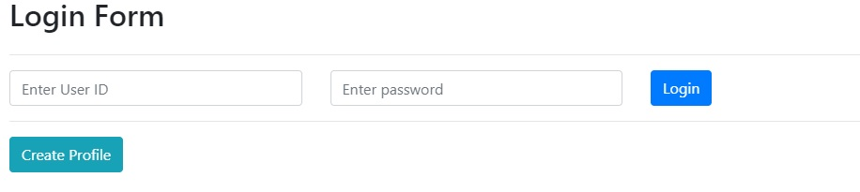

Before login user has to register hence user will click on Create Profile which will show below screen;

Screen2: Registratio Form, if you try to missout any field a validation error must be shown in the page

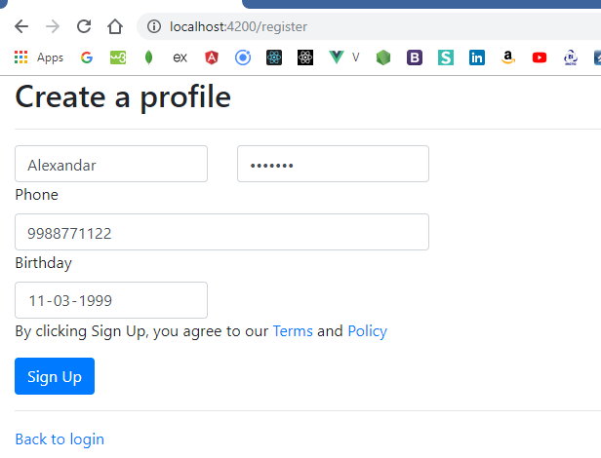

When user registers it redirects to login as below

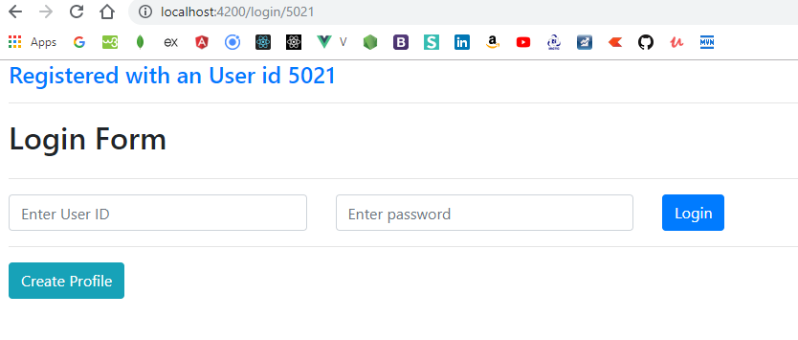

Now the user will login with 5021 and password which will not have any contacts by default, when he logs in if the authentication fails below would be the error.

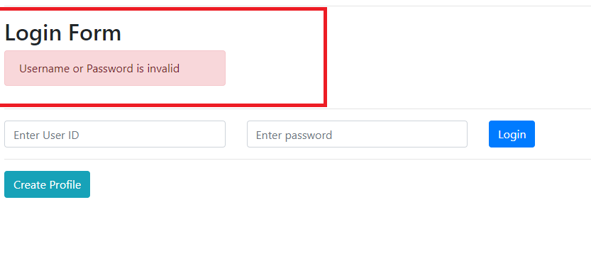

When the user enters correct userid and password user will be taken to dashboard

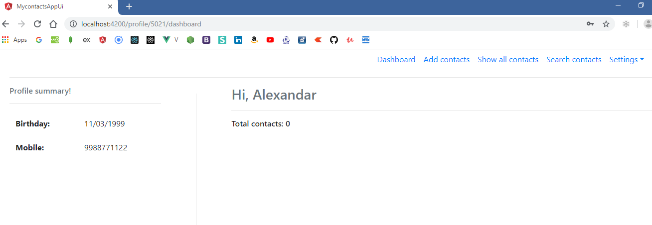

Notice the paths like profile/5021/dashboard, and the Total Contacts in the dashboard, settings link, profile summary,

When you go to add contacts you will

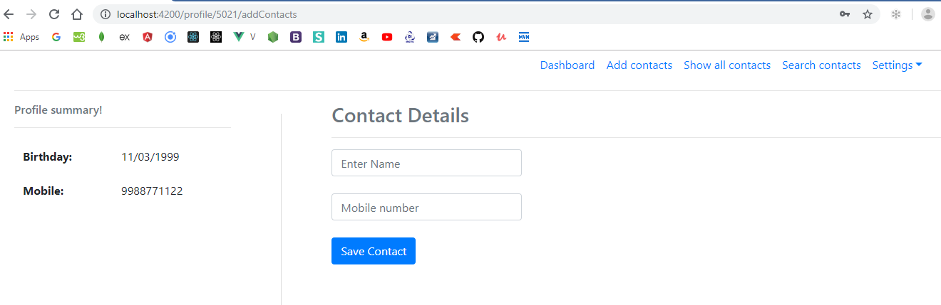

You can add contacts, but notice the url it always have the userId after profile like profile/5021/addContacts, you can add contacts now

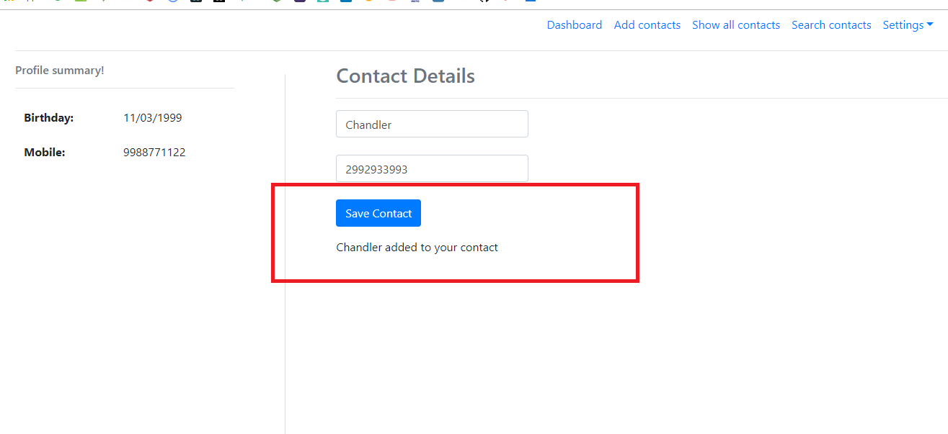

Now you can click on dashboard that shows the contact count as 1, earlier it was 0, you can add any number of contacts

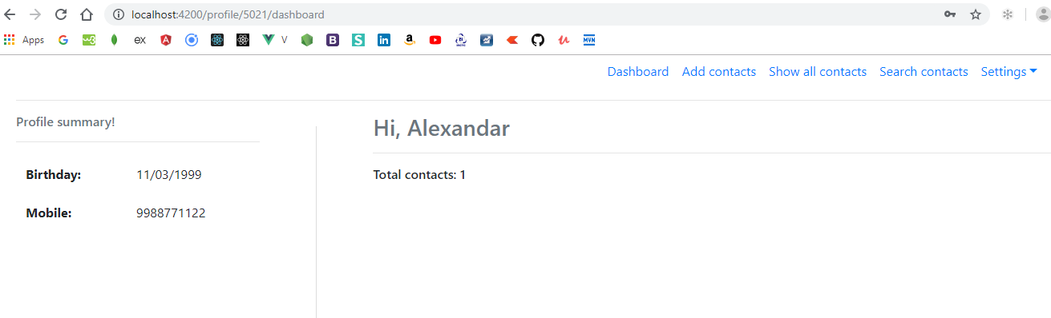

Again notice the url which has the 5021, you will always have the userId in the url that’s how you will make a call to the back end server, After adding few more user this would be the dashboard

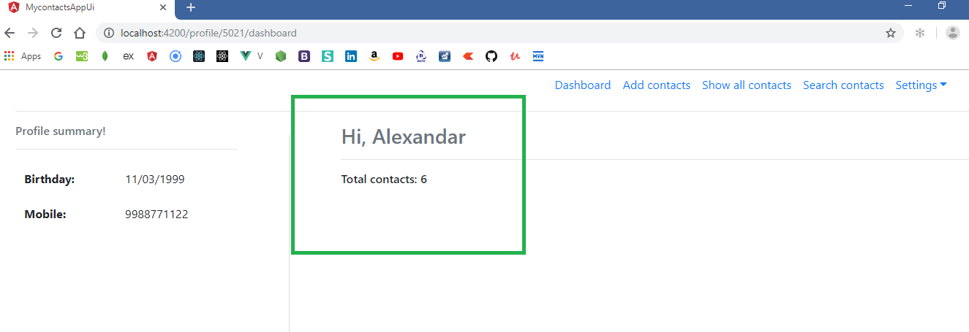

Show all contacts will show you below details

You will see a delete button and also the url is now profile/5021/showAllContacts

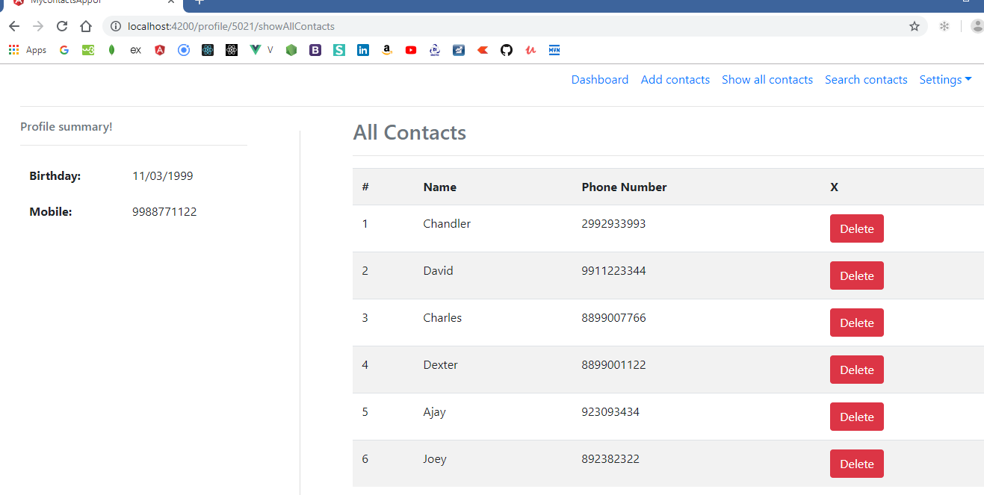

If you delete contact you will see a message

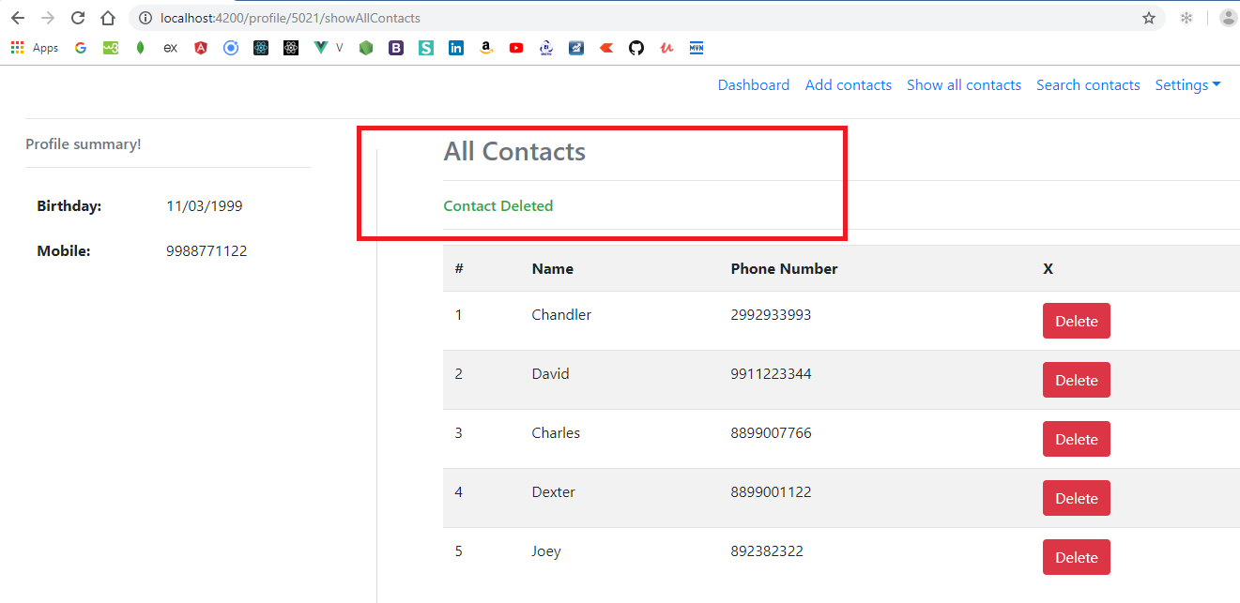

When you delete all contacts you will see the message like below

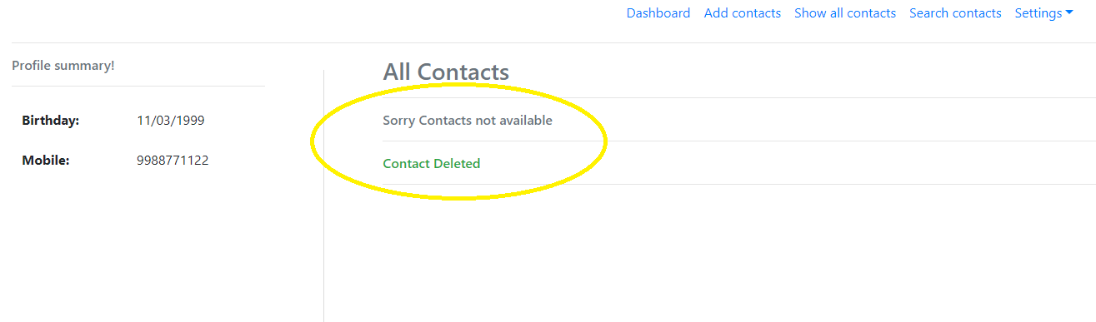

You can change the profile by visiting the settings which is a drop down like below:

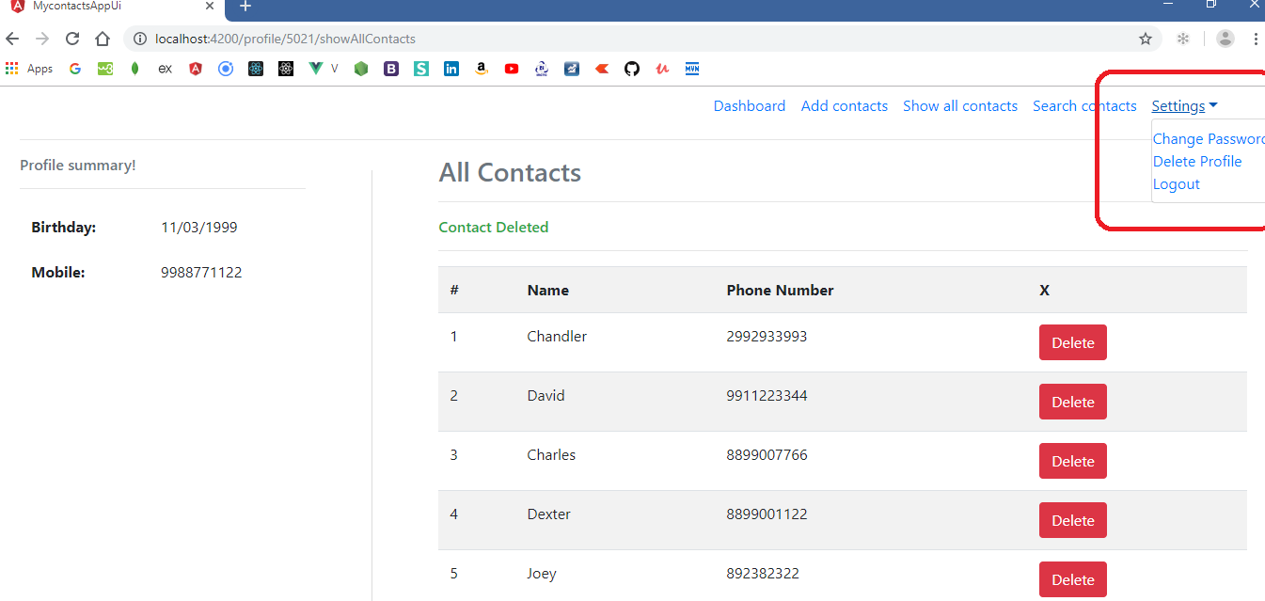

When you click on change password you will go to update as below, here you can update the password if you want

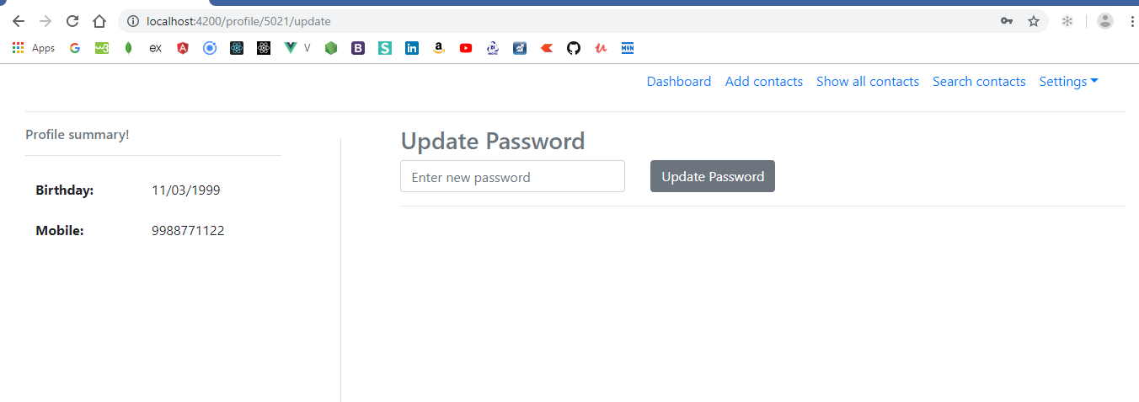

After updating the password

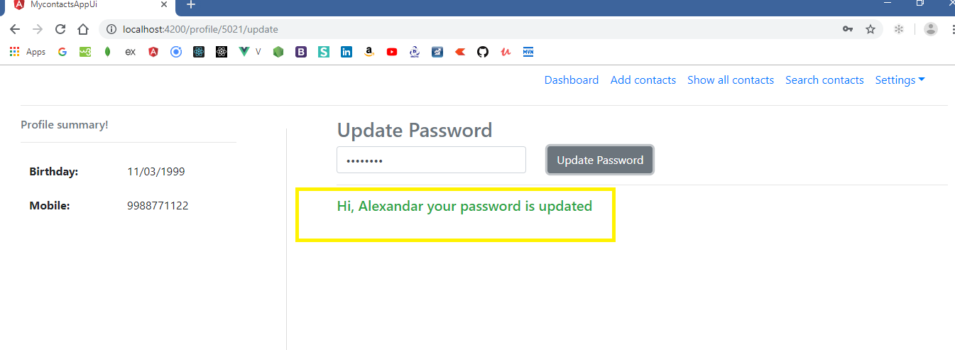

You can also delete profile if you want by going to delete profile in the settings that looks as below

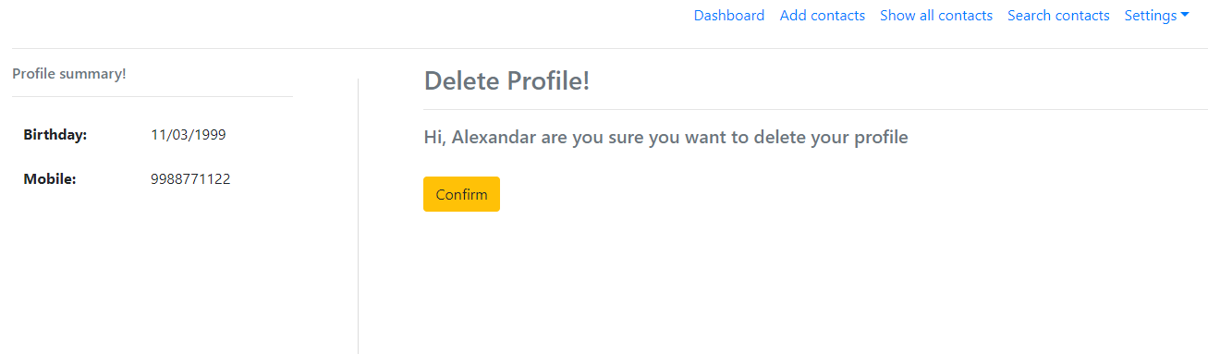

If you click on Confirm it will delete the profile and automatically go to Login page, just to keep the profile in database it is not deleted but if you wish to delete you would not able to login and also all contacts will be erased automatically.

Search Contacts link, Assuming you have these below 4 contacts in the database

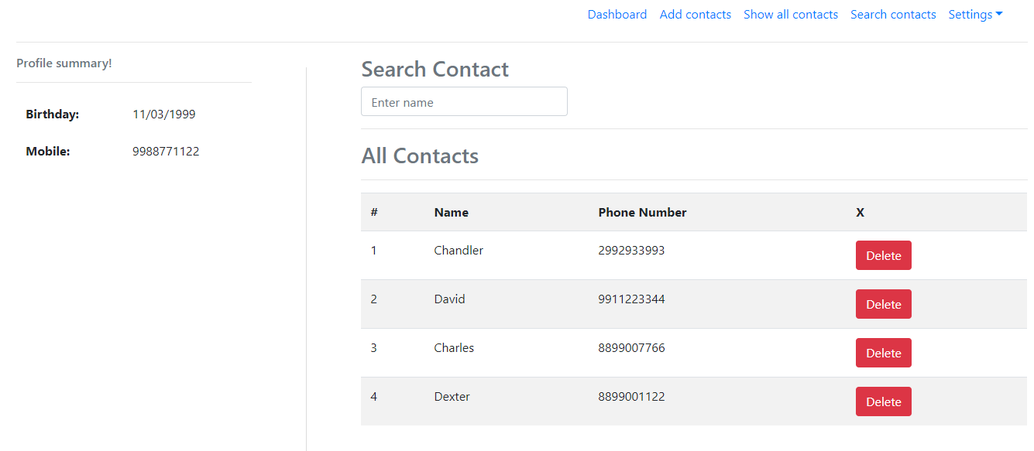

Now if you enter C you would only see the contacts starting with C as below:

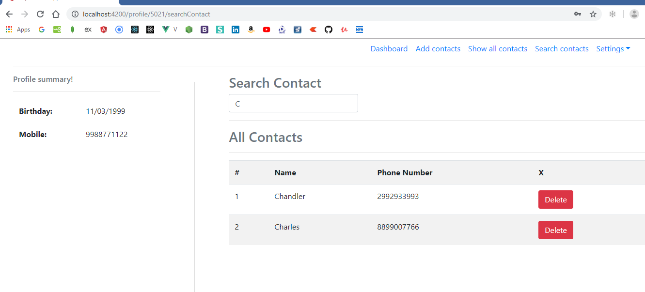

You can delete the contact if you would like, this search component make use of show all components internally

If the matching records not found below would be the error message it can show

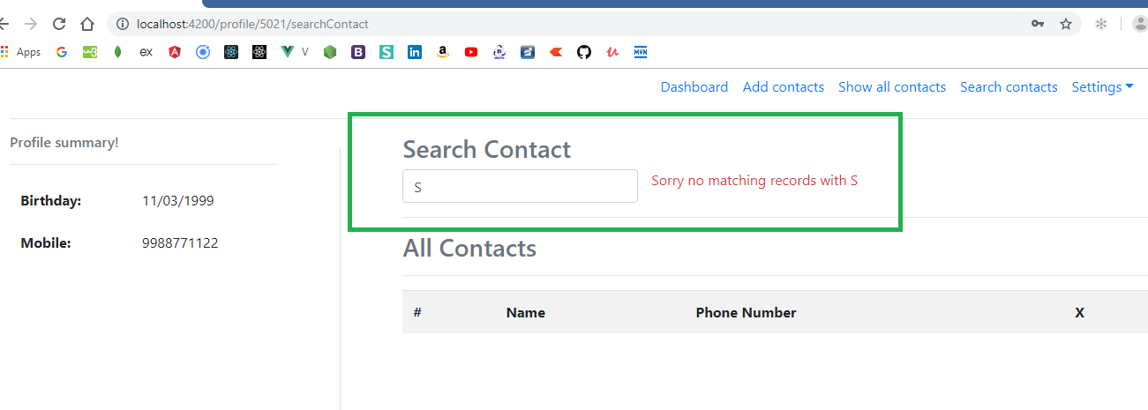

Now you can logout: It will show you login page again

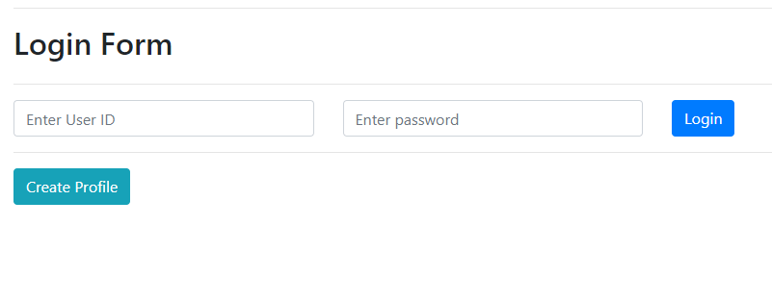

You can enhance the application to update the user phone, dob, update the contact details also.